Web Server (Apache)Pending
Tasks
1.Install Apache web server on your Linux system and verify the installation by accessing the default Apache welcome page from your browser using localhost.

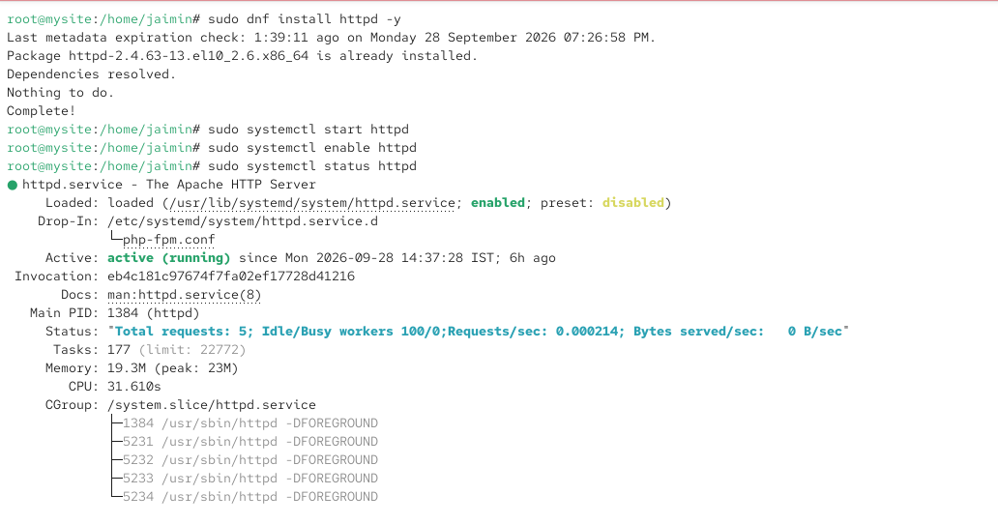
2.Change the default Apache web server homepage by editing the index.html file in /var/www/html to display your name and favorite IPL team.
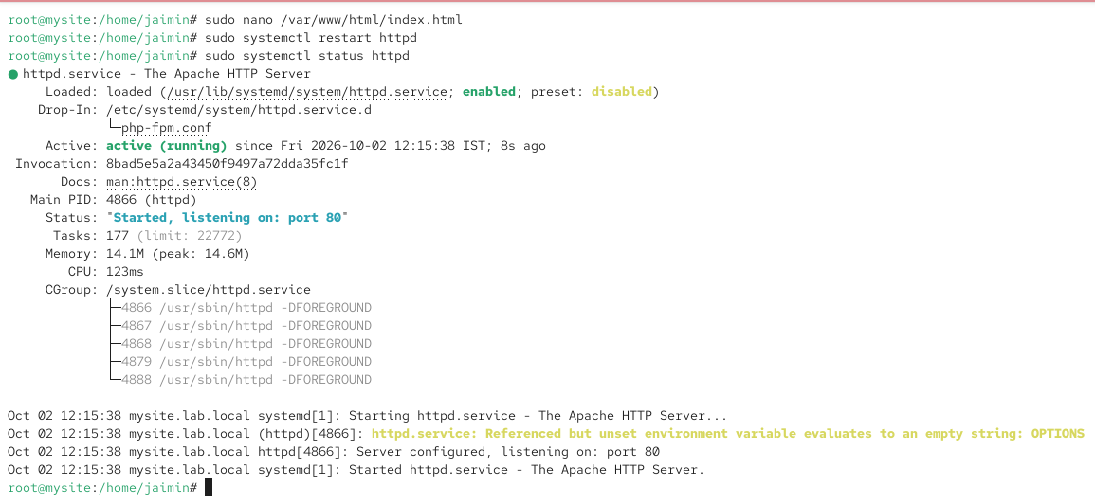
3.Configure a custom virtual host in Apache for a new domain called myzomatoclone.local that serves files from /var/www/myzomatoclone and test it by updating your /etc/hosts file.

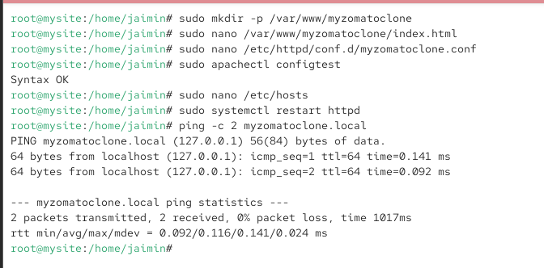

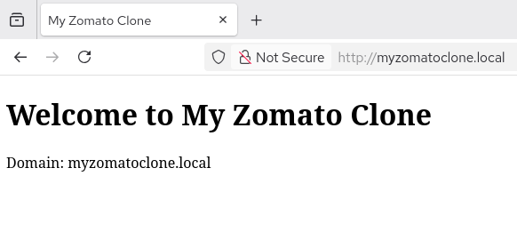
4.Enable and test the Apache mod_rewrite module by creating a rule that rewrites requests from /foodie to /index.html, then verify it works in your browser.Hint: Use the a2enmod command and edit the .htaccess file in your web root.

